# ADS-A

**CHALLENGE: DATA-DRIVEN ORGANISATIONS**

REPORT FOR VDL APPARATENBOUW

horizontal line

# 

# 

Contents

1

Introduction 3

Motive and functional Proficiency 4

Business Challenges & Key Obstacle 4

Data management and Analytics in action maturity explanation: 5

Machine Learning Applicable: 6

Data Maturity matrix 6

Feedback : 7

Conclusion: 7

Reflection: 7

# Introduction

Most organizations wishing to become data-driven mention that their number one priority for doing so is "integration", yet their organizational structure is departmentalized and data is stored in "silos", using different formats and perhaps copying information from other departments over and over (redundancy and consistency).

Also, it is a human tendency to make a decision for the future based on intuition (and perhaps some personal experience) rather than on actual data, especially if the data seems to go against common wisdom. One might wonder why top strategic decisions are often still made by (groups of) humans and not by "data machines"/computers.

**VDL Apparatenbouw**

VDL Apparatenbouw is a system supplier in the field of (complex) medical, optical mechatronic modules and products. VDL Apparatenbouw also has experience in assembling filter and tank installations for the agricultural and chemical industries. VDL Apparatenbouw also has experience in working for companies in the consumer market. The size of the modules that VDL Apparatenbouw assembles varies from manageable up to and including the size of a sea container. VDL Apparatenbouw usually works together with experienced OEM companies, but prototyping and co-development are also possible at VDL Apparatenbouw.

I decided to know whether​ VDL is data-driven or the other way around, and if it is data-driven, which level they are currently on. Therefore, I conducted an interview on one of their employee, her name is ​Nicole Celine​. During the interview, I requested that she fill in the survey form and a few questions that would enable us to classify the organization depend on the three distinct data-driven maturity levels. Afterward, I broke down the appropriate responses with the data-driven maturity matrix to figure out which level is ​VDL​ on right now.

# 

# Motive and functional Proficiency

After going through the interview it's obvious that VDL collects, stores and analyses their data on a frequent level, due to the company policy regarding data I was not able to know for sure if the company at a level that they build their strategies totally based on the data they analyze or if data only plays a role in guiding these strategies but I know for sure that the company is sees data as an essential factor in determining strategies. And have achieved a level where data affects making decisions regarding customer service and satisfaction and regarding their products management.

They also used data for their financial management and budgeting to make sure that the company financial condition is in good shape. They also used data in their production company where the data that they’re store going to be on their supply chain where it’s consistently produce product for their customer and the company used data for their research and development regarding new innovation that they’re going to make because as a manufacture company they need to adapt and make new innovation otherwise, they can lose their customer and potential customer. Customer service also highly important for them because need to make sure every client that they have satisfy by the company work.

# Business Challenges & Key Obstacle

Based on the questionnaire that I had, I can make the conclusion that VDL used data frequently regarding Business Challenges. Their department used data to determine what action should I take for future planning, increase the efficiency of their products and develop new ones. For instance, VDL Logistic department used the record of how long does it takes to transport a product, after that the record will serve as a guide to improve their transport time of which route is the fastest to reach its destination in order to reduce transport time also the operation cost of the logistic. Another example is they also used data to research the scale of customer satisfaction in their company, in order to earn customer loyalty and to have a good image as a company. The conclusion that I get from the survey VDL used data to increase their revenue as their primary focus and maintaining customer relationships as their targeted focus. They also used data as a tool determining which strategy should they choose such as, if their bus division sales are regressing, they will do research to find a place in which demand of bus is still high to increase their revenue.

A Company always has an obstacle that they must encounter, in this section, I’m going to explain the VDL obstacle regarding Data-driven. Based on the questionnaire VDL have 2 main key obstacle the first one is a problem in accessing data in general and the second one is sometimes the data that they get considered as low-quality data however to be a successful company they must face and of problem.

# Data management and Analytics in action maturity explanation:

The company seems to have a strong ability to manage their data. They have a suitable infrastructure, updated knowledge about data handling and willing to spend the budget to invest in this area. They can get data and analyze it reasonably to achieve the information needed. However, the data is likely as low quality, they cannot access every data that is collected and is only handed the data that is needed. Limiting data also leads to the restriction in the amount of information that could also be shared.

Last but not least, companies must take adequate action to resolve issues. According to the results of the interview, they are putting more effort to resolve the problem when the decisions are on at some points strategic level. Furthermore, as they constantly receive data, they use them to get insights that would then be used to develop the organization to guide them in their daily activities.

# 

# Machine Learning Applicable:

In the abstract, there is compelling evidence to invest in machine learning. But how do organizations really use this technology? In what ways is machine learning deployed today to help companies create value, cut costs and drive ROI?

First of all, the company should apply it to user acquisition. In broad strokes, the customer acquisition funnel for a typical consumer or enterprise business has three stages: segmenting your customer base to understand and address their needs, engaging them with the right messaging at the right time, and converting them into users of your product. Machine learning has seen wide use by startups and major corporations alike across the entire user acquisition funnel. For instance, they could use machine learning to adjust branding, copy and promotional pricing on the fly to maximize the likelihood of a sale for any given customer.

They can also improve their customer service to more readily increase their satisfaction. For example, Brazilian supermarket Ocado used Google machine learning APIs to build a custom system that measures the sentiment of customer support inquiries and moves negative responses to the top of the support cue. The result is that Ocado responds to urgent messages four times faster, creating a valuable opportunity to win back customers at high risk of becoming detractors.

In the back office, a wide variety of organizations are starting to use machine learning to build more robust, granular and accurate forecasting models. That applies well with VDL for the reason that they put the determination of a strategy based on data and analysis into one of the company’s top priorities.

# 

# Data Maturity matrix

I believe that VDL Apparatenbouw scores the following results in our Maturity Matrix:

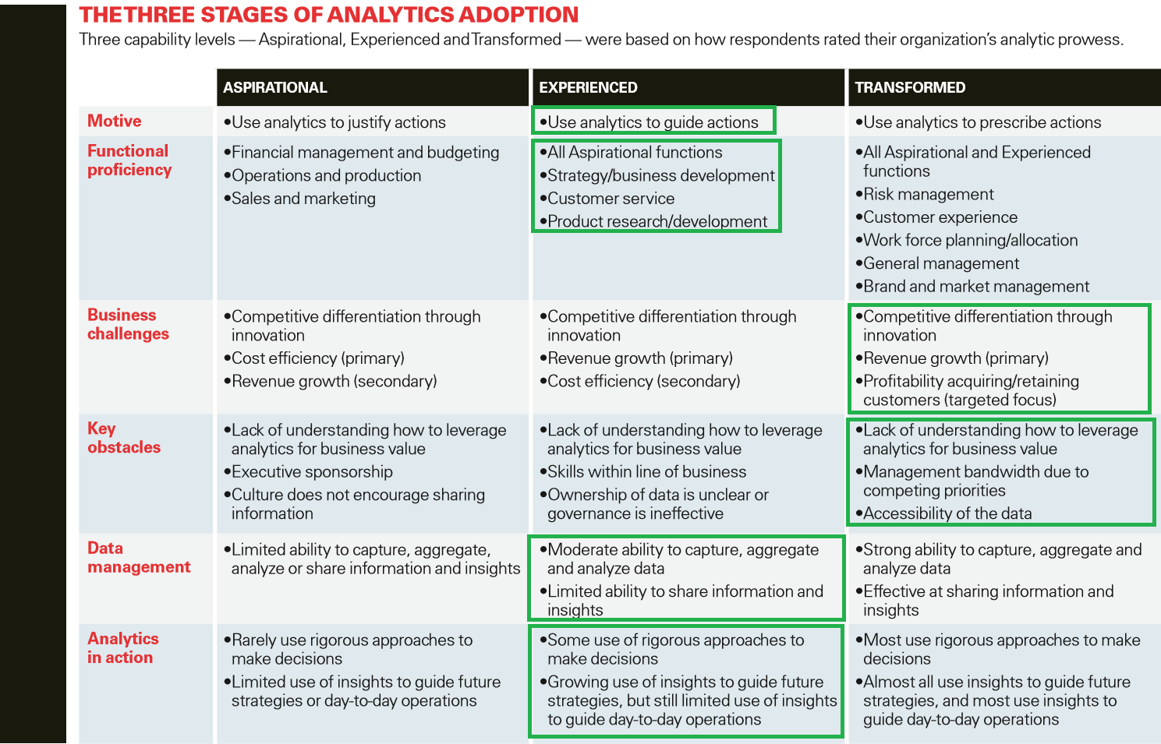

# Feedback:

The analyses report gives the company a clear idea how to fix our problem in supply chain

# Conclusion:

I believe that the data-driven maturity level of the organization is Experienced.

# Reflection:

According to the feedback of the company, I believe that I have accomplished every task of the challenges. However, in the following weeks of the course, I will try to learn different skills to give more details analytics into the company’s business.